Program 1 – Write a program to print Fibonacci series.
Sol:
import java.lang.*;
import java.util.Scanner;

public class FibonacciSeries
{
public static void main(String[] args)
{
Scanner sc=new Scanner(System.in);
System.out.println("Enter the no. of terms in the series:");
int n=sc.nextInt();
fibonacci(n);
}

public static void fibonacci(int n)
{
int a=0,b=1,c;
if(n==0)
{
System.out.println("Invalid entry.");
}
if(n==1)
{
System.out.println(a);
}
if(n>=2)
{
System.out.println(a);
System.out.println(b);
while(n>2)
{
c=a+b;
a=b;
b=c;
System.out.println(c);
n--;
}
}
}
}
Output:

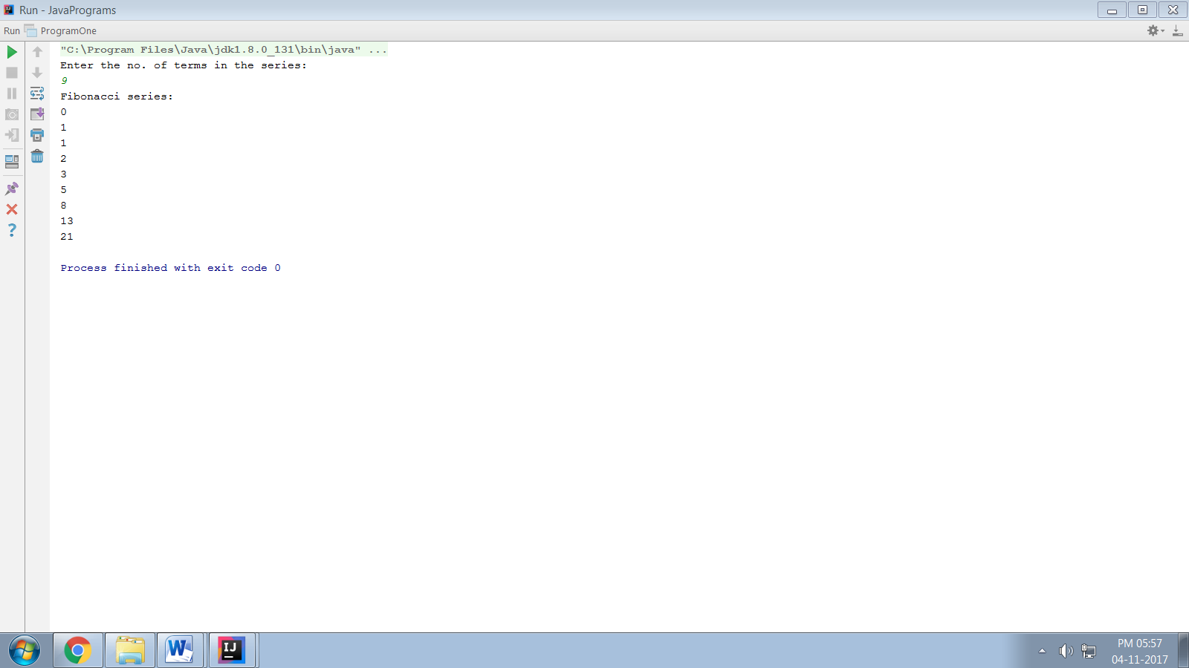
Program 2 - Write a program to print the following patterns:-
1 1 1
22 12 12
333 123 123
4444 1234 1234
55555 12345 12345
Sol:

import java.lang.*;
public class Patterns {
public static void main(String[] args) {
int count=1;
int i=0,j=0;
for(i=0;i<5;i++){
for(j=0;j<=i;j++){
System.out.print(count);
}
System.out.println();
count++;
}
for(i=0;i<5;i++){
count=1;
for(j=0;j<=i;j++){
System.out.print(count);
count++;
}
System.out.println();
}
for(i=0;i<5;i++){
for(j=4;j>i;j--){
System.out.print(" ");
}
count=1;
for(j=0;j<=i;j++){
System.out.print(count);
count++;
}
System.out.println();
}
}
}

Output:

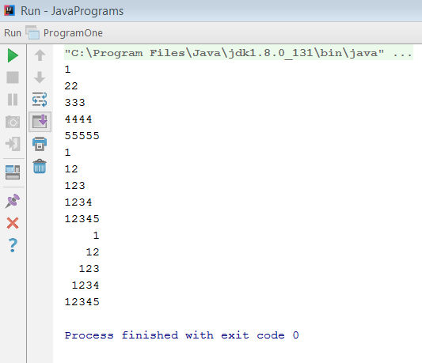

Program 3 - Write a program to read the given input array of marks and find the allocated division as follows:-
Marks Division
>= 80 Honors
>= 60 and <= 79 First Division
>= 40 and <= 59 Second Division
>= 30 and <= 39 Third Division
Else Fail
Sol:
import java.util.Scanner;
import java.lang.*;
public class Divisions {
public static void main(String[] args) {
Scanner sc=new Scanner(System.in);
float marks=0;
float[] m=new float[4];
int n=0;
System.out.println("Enter Marks for PHYSICS, CHEMISTRY, MATHS and CS:");
while (n<4) {
m[n]=sc.nextFloat();
n++;
}
marks=(m[0]+m[1]+m[2]+m[3])/n;

if(marks>=80){
System.out.println("Honors");
System.out.println("Marks:"+marks);
}
else if(marks>=60 && marks<80){
System.out.println("First Division");
System.out.println("Marks:"+marks);
}
else if(marks>=40 && marks<60){
System.out.println("Second Division");
System.out.println("Marks:"+marks);
}
else if(marks>=30 && marks<40){
System.out.println("Third Division");
System.out.println("Marks:"+marks);
}
else{
System.out.println("Fail");
System.out.println("Marks:"+marks);
}
}

}
Output:

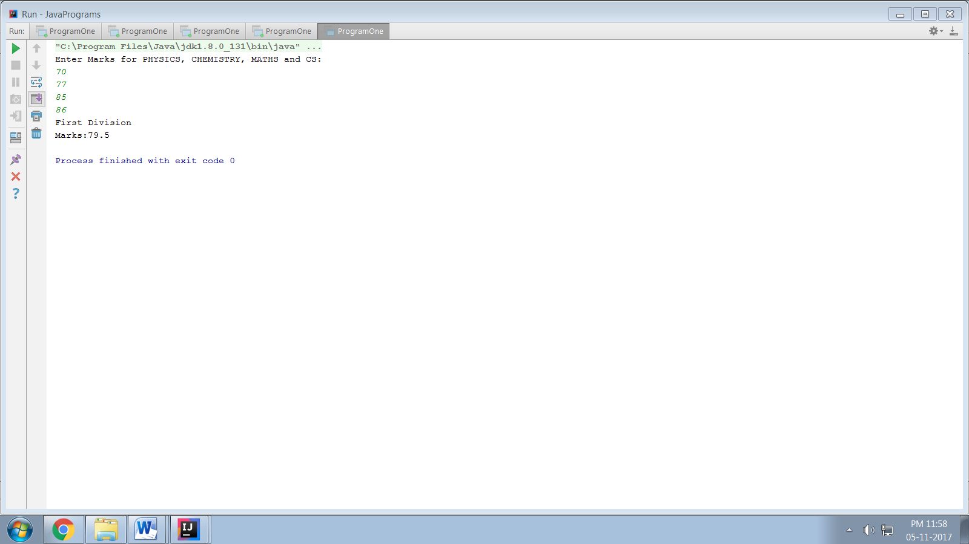
PROGRAM 4 - Write a program that has overloaded methods. The first method should accept no arguments, the second method will accept one string and the third method will accept a string and an integer. The first method should display the message “Rose is a beautiful flower” twice. The second method should display the message “Sunflower is a beautiful flower” five times. The third method should display the message “Marigold is a beautiful flower” by number of times values received in the argument.
Sol:

import java.util.*;

public class ProgramFour {
public static void main(String[] args) {
ProgramFour obj=new ProgramFour();
obj.Flowers();
obj.Flowers("Sunflower is a beautiful flower.");
obj.Flowers("Marigold is a beautiful flower.",10);
}
public void Flowers(){
int i=1;
while(i<=2) {
System.out.println("Rose is a beautiful flower.");
i++;
}
}
public void Flowers(String str){
int i=1;
while(i<=5) {
System.out.println(str);
i++;
}
}
public void Flowers(String str, int n){
int i=1;
while(i<=n) {
System.out.println(str);
i++;
}
}
}
Output:

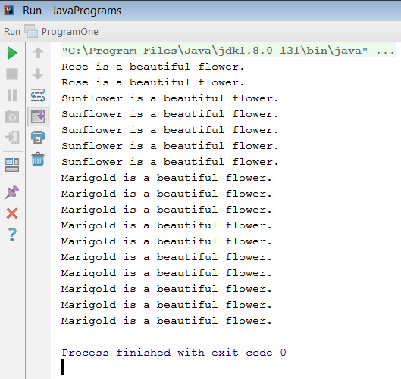
PROGRAM 5 - Write a Java Program to define a class, describe its constructor, overload the Constructors and instantiate its object.
Sol:

#include<graphics.h>
#include<stdio.h>
#include<conio.h>
PROGRAM 6 - Create a class called Numeral that has an array of 10 integers. Create a subclass called NumberPlay which has a menu as follows:-
a) Display numbers entered
b) Sum of the numbers
c) Average of the numbers
d) Maximum of the numbers
e) Minimum of the numbers
Sol:

#include <graphics.h>
#include <iostream.h>
#include <conio.h>

PROGRAM 7 - Write a program that will display the message “Weight of bundle- 5 kg” in a constructor and display the weight in kilograms and grams passed as an argument.
Sol:

#include <graphics.h>
#include <iostream.h>
#include <conio.h>

PROGRAM 8 - Create an abstract class Shape to describe a shape with two dimensions. Define a method to display the area of shape. Create two subclasses: Rectangle and Triangle. Call the display function using reference variable of the class shape.
Sol:

#include <graphics.h>
#include <iostream.h>
#include <conio.h>

PROGRAM 9 - Write a program to create an array of string and sort the array elements in alphabetical order.
Sol:

#include <graphics.h>
#include <stdio.h>
#include <stdlib.h>

PROGRAM 10 - Write a Java Program to implement inheritance and demonstrate use of method overriding.
Sol:

import java.lang.*;

class Employee
{
public void DisplayEmployee()
{
System.out.println("Displaying the Employee Base class!!");
}
}

class PartTimeEmployee extends Employee
{
public void DisplayEmployee()
{
System.out.println("Displaying the PartTimeEmployee!!");
}
}

public class Main
{
public static void main(String[] args)
{
System.out.println("Inheritance and Method Overriding:\n\n");

Employee EE = new Employee();
EE.DisplayEmployee();

//This is Method Overriding
PartTimeEmployee PT = new PartTimeEmployee();
PT.DisplayEmployee();
}
}
Output:

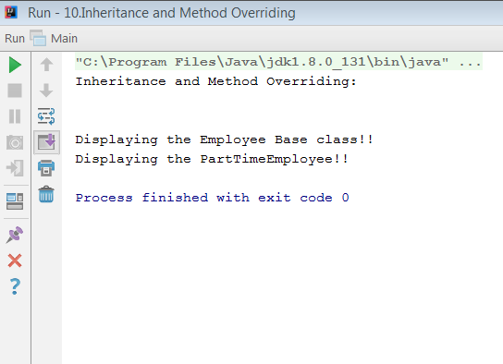

PROGRAM 11 - Write a program to demonstrate use of implementing interfaces.
Sol:

import java.lang.*;

interface IDrawable
{
void draw();

static int cube(int x)
{
return x * x * x;
}

}

class Rectangle implements IDrawable
{

//Implementing the Interface method here...
public void draw()
{
System.out.println("drawing rectangle");
}

}

public class Main
{
public static void main(String[] args)
{

Rectangle RR = new Rectangle();
RR.draw();

//Accessing the static method through the Interface
int cubeRoot = IDrawable.cube(3);
System.out.println("The cube root of 3 is " + cubeRoot);

}

}
Output:

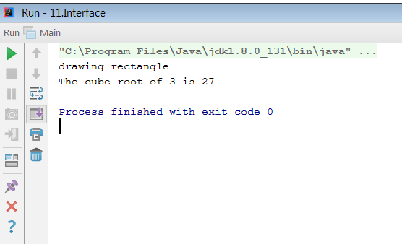
PROGRAM 12 - Write a Java Program to implement multilevel inheritance by applying various access controls to its data members and methods.
Sol:

import java.lang.*;

class Car
{
public Car()
{
System.out.println("Class Car");
}
public void vehicleType()
{
System.out.println("Vehicle Type: Car");
}
}

class Maruti extends Car
{
public Maruti()
{
System.out.println("Class Maruti");
}
public void brand()
{
System.out.println("Brand: Maruti");
}
public void speed()
{
System.out.println("Max: 160Kmph");
}
}

class Maruti800 extends Maruti
{
public Maruti800()
{
System.out.println("Maruti Model: 800");
}
public void speed()
{
System.out.println("Max: 120Kmph");
}

}

class Main
{

public static void main(String args[])
{

Maruti800 obj = new Maruti800();
obj.vehicleType();
obj.brand();
obj.speed();

}

}
Output:

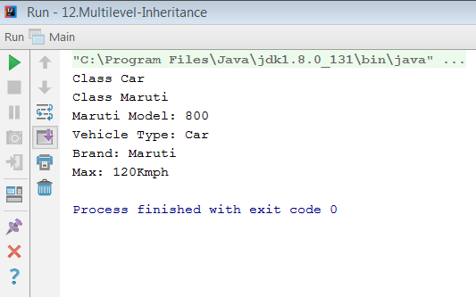
PROGRAM 13 - Write a program to create three thread class A, B and C. Thread class A will print each value of defined array, B class will print a message 10 times. Class C will responsible for printing the value from 1 to 10 and sleep for few times when reached the value 5.
Sol:

import java.lang.*;

class ClassA extends Thread
{
public void run()
{
int[] intArray = new int[]{1, 2, 3, 4, 5};
for (int i : intArray)
{
System.out.println("Thread A: "+i);
}
}
}

class ClassB extends Thread
{
public void run()
{
String message = "This is the sample text!!";
for (int i = 0; i < 10; i++)
{
System.out.println("Thread B: "+(i+1)+". "+message);
}
}
}

class ClassC extends Thread
{
public void run()
{
for (int i = 1; i <= 10; i++)
{
if (i == 5)
{
try
{
sleep(1000);
}
catch (InterruptedException e)
{
e.printStackTrace();
}
}
else
{
System.out.println("Thread C: "+i);
}
}
}
}

public class Main
{
public static void main(String[] args)
{
//it prints no. of values in the array
ClassA threadA = new ClassA();
threadA.start();

//it shows the message 10 times
ClassB threadB = new ClassB();
threadB.start();

//it shows the 1 to 10 integer values
ClassC threadC = new ClassC();
threadC.start();

}
}
Output:

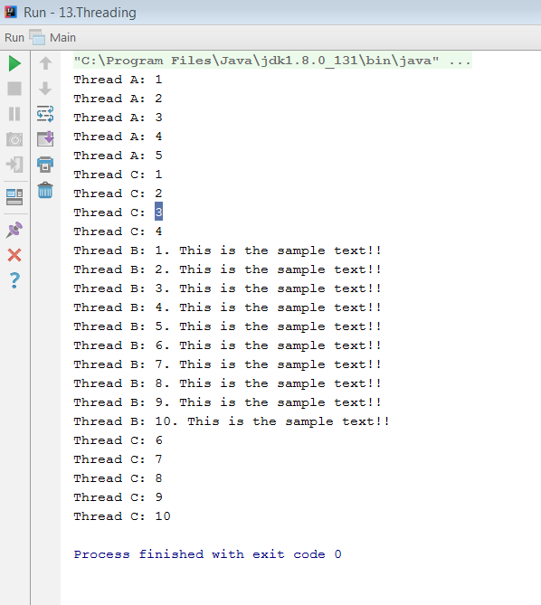
PROGRAM 14 - Write a program using HTML to create a virtual lab related to any subject of your choice.
Sol:

#include <graphics.h>
#include <stdlib.h>
#include <stdio.h>

PROGRAM 15 - Write a program using HTML to prepare a simple student registration form.
Sol:

<html>
<head>
<script type="text/javascript">
function ValidateForm()
{
alert("Form submitted successfully!!!");
}
</script>
</head>

<body bgcolor="silver" bolder="5">
<form action="#" name="StudentRegistration">
<table cellpadding="2" width="50%" border="10" align="center" cellspacing="2">
<tr>
<td colspan=2><center><font size=4><b>Student Registration Form </b></font></center></td>
</tr>

<tr>
<td>Name</td>
<td><input type=text name=textnames id="textname" size="30"></td>
</tr>

<tr>
<td>Father Name</td>
<td><input type="text" name="fathername" id="fathername"
size="30"></td>
</tr>

<tr>
<td>Postal Address</td>
<td><input type="text" name="paddress" id="paddress" size="30"></td>
</tr>

<tr>
<td>Personal Address</td>
<td><input type="text" name="personaladdress"
id="personaladdress" size="30"></td>
</tr>

<tr>
<td>Sex</td>
<td><input type="radio" name="sex" value="male" size="10">Male
<input type="radio" name="sex" value="Female" size="10">Female</td>
</tr>

<tr>
<td>City</td>
<td><select name="State">
<option value="-1" selected>select..</option>
<option value="New Delhi">New DELHI</option>
<option value="Mumbai">MUMBAI</option>
<option value="Kolkata">Kolkata</option>
<option value="Patna">Patna</option>
</select></td>
</tr>

<tr>
<td>Course</td>
<td><select name="Course">
<option value="-1" selected>select..</option>
<option value="B.Tech">B.TECH</option>
<option value="MCA">MCA</option>
<option value="MBA">MBA</option>
<option value="BCA">BCA</option>
</select></td>
</tr>

<tr>
<td>District</td>
<td><select name="District">
<option value="-1" selected>select..</option>
<option value="East">East</option>
<option value="West">West</option>
<option value="North">North</option>
<option value="South">South</option>
</select></td>
</tr>

<tr>
<td>State</td>
<td><select Name="State">
<option value="-1" selected>select..</option>
<option value="Delhi">DELHI</option>
<option value=" Maharashtra">Maharashtra</option>
<option value="Kolkata">Kolkata</option>
<option value="Bihar">Bihar</option>
</select></td>
</tr>
<tr>
<td>PinCode</td>
<td><input type="text" name="pincode" id="pincode" size="30"></td>
</tr>

<tr>
<td>EmailId</td>
<td><input type="text" name="emailid" id="emailid" size="30"></td>
</tr>

<tr>
<td>DOB</td>
<td><input type="text" name="dob" id="dob" size="30"></td>
</tr>

<tr>
<td>MobileNo</td>
<td><input type="text" name="mobileno" id="mobileno" size="30"></td>
</tr>

<tr>
<td><input type="reset"></td>
<td colspan="2"><input type="submit" value="Submit Form" onclick="ValidateForm()" /></td>
</tr>
</table>
</form><br><br>
</body>

</html>
Output:

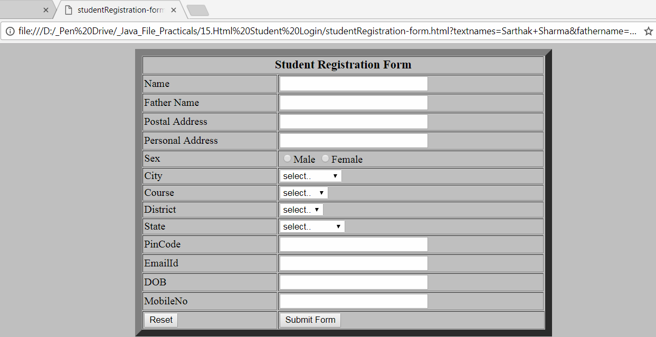

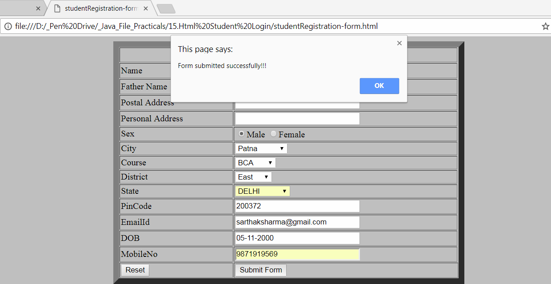
PROGRAM 16 – Write a program to show the functioning of at least 10 string handling function.
Sol:

import java.lang.*;

public class Main
{
public static void main(String[] args) {

String str= "Welcome java Geeks!!!";

System.out.println("String: "+str);

System.out.println("Index of 'G' is: "+str.indexOf('G'));
System.out.println("Index of 'c' from 3: "+str.indexOf('c', 3));

String subString="java";
System.out.println("index of substring 'java' :"
+str.indexOf(subString));

System.out.println("Char at index 2 is:"+str.charAt(2));

System.out.println("lowercase string is: "
+str.toLowerCase());

System.out.println("UPPERCASE string is: "
+str.toUpperCase());

System.out.println("Length of string is: "+str.length());

System.out.println("Replacing 'j' from 'java' with 'J': "
+str.replace('j','J'));

System.out.println("Removing the whitespace: "+str.trim());

int num = 35;
String s1 = String.valueOf(num);
System.out.println("Converting number: "+num+" into string: "
+s1);
}
}
Output:

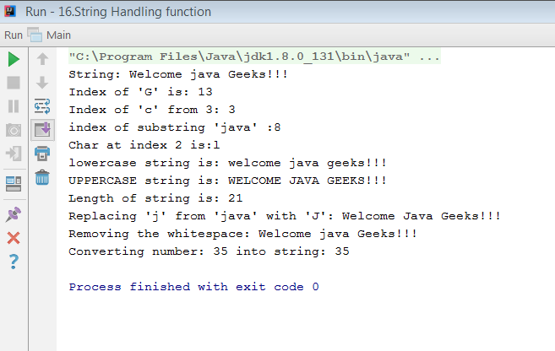
PROGRAM 17 - Write a program to show the functioning of vector.
Sol:

import java.lang.*;
import java.util.Enumeration;
import java.util.Vector;

public class Main
{

public static void main(String[] args)
{
Vector vec = new Vector(2);

vec.addElement(22);
vec.addElement(33);
vec.addElement(44);
vec.addElement(55);

System.out.println("Vector size is: " + vec.size());
System.out.println("Default capacity increment is: " +
vec.capacity());

vec.addElement(66);
vec.addElement(77);
vec.addElement(88);

System.out.println("Size after addition: " + vec.size());
System.out.println("Capacity after increment is: " +
vec.capacity());

Enumeration en = vec.elements();
System.out.println("\nValues are:");

while (en.hasMoreElements())
System.out.print(en.nextElement() + " ");

}

}
Output:

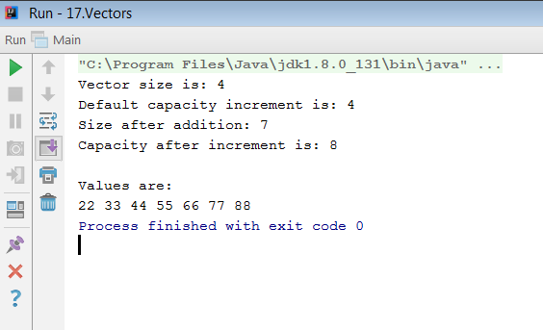
PROGRAM 18 - Write a program using applet to handle the various checkbox events.
Sol:

import java.applet.Applet;
import java.awt.*;
import java.awt.event.ItemEvent;
import java.awt.event.ItemListener;

public class HandleCheckboxEvent extends Applet implements ItemListener {
private Checkbox java = null;
private Checkbox C = null;
private Checkbox Cpp = null;

public void init(){
//creating checkboxes
java = new Checkbox("Java");
C = new Checkbox("C");
Cpp = new Checkbox("C++");
add(java);
add(C);
add(Cpp);

//add item listeners to the checkboxes
java.addItemListener(this);
C.addItemListener(this);
Cpp.addItemListener(this);
}

public void paint(Graphics g){
g.drawString("Java: " + java.getState(),10,80);
g.drawString("C: " + C.getState(), 10, 100);
g.drawString("C++: " + Cpp.getState(), 10, 120);
}

public void itemStateChanged(ItemEvent ie){
repaint();
}

/*
<applet code="HandleCheckboxEvent" width=200 height=200>
</applet>
*/

}

Output:

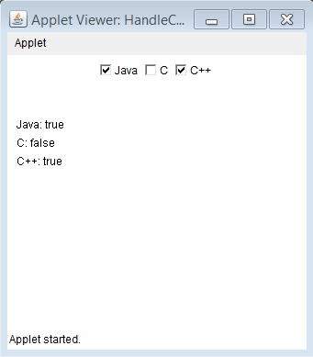
PROGRAM 19 - Write a program using applet to handle the button click event.
Sol:

#include<stdio.h>
#include<time.h>
#include<conio.h>

PROGRAM 20 - Write a program using AWT to implement a simple calculator.
Sol:

import java.awt.*;
import java.awt.event.ActionEvent;
import java.awt.event.ActionListener;

class Calculator implements ActionListener {
//Declaring Objects
Frame f = new Frame();
Label l1 = new Label("First Number");
Label l2 = new Label("Second Number");
Label l3 = new Label("Result");

TextField t1 = new TextField();
TextField t2 = new TextField();
TextField t3 = new TextField();

Button b1 = new Button("Add");
Button b2 = new Button("Sub");
Button b3 = new Button("Mul");
Button b4 = new Button("Div");
Button b5 = new Button("Cancel");

Calculator(){
//Setting Coordinates
l1.setBounds(50, 100, 100, 20);
l2.setBounds(50, 140, 100, 20);
l3.setBounds(50, 180, 100, 20);

t1.setBounds(200, 100, 100, 20);
t2.setBounds(200, 140, 100, 20);
t3.setBounds(200, 180, 100, 20);

b1.setBounds(50, 250, 50, 20);
b2.setBounds(110, 250, 50, 20);
b3.setBounds(170, 250, 50, 20);
b4.setBounds(230, 250, 50, 20);
b5.setBounds(290, 250, 50, 20);

//Adding components to the frame
f.add(l1);
f.add(l2);
f.add(l3);

f.add(t1);
f.add(t2);
f.add(t3);
f.add(b1);
f.add(b2);
f.add(b3);
f.add(b4);
f.add(b5);

b1.addActionListener(this);
b2.addActionListener(this);
b3.addActionListener(this);
b4.addActionListener(this);
b5.addActionListener(this);

f.setLayout(null);
f.setVisible(true);
f.setSize(400, 350);
}
@Override
public void actionPerformed(ActionEvent e) {
int n1 = Integer.parseInt(t1.getText());
int n2 = Integer.parseInt(t2.getText());

if (e.getSource() == b1) {
t3.setText(String.valueOf(n1 + n2));
}

if (e.getSource() == b2) {
t3.setText(String.valueOf(n1 - n2));
}

if (e.getSource() == b3) {
t3.setText(String.valueOf(n1 * n2));
}

if (e.getSource() == b4) {
t3.setText(String.valueOf(n1 / n2));
}

if (e.getSource() == b5) {
System.exit(0);
}
}
}
class Main{
public static void main(String[] args){
Calculator cc= new Calculator();
}
}
Output:

MULTIPLICATION:
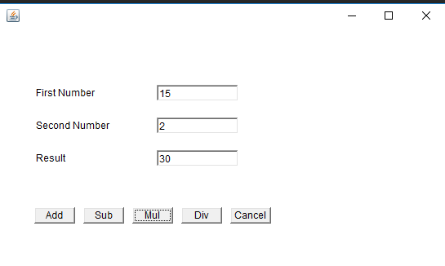

ADDITION:
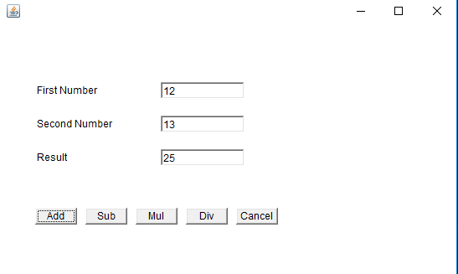

PROGRAM 21 - Write a program using AWT to implement a simple student registration form.
Sol:

#include<stdio.h>
#include<time.h>
#include<conio.h>
#include<graphics.h>

PROGRAM 22 - Write a program to convert a decimal number into binary and vice versa.
Sol:

#include<stdio.h>
#include<time.h>
#include<conio.h>

PROGRAM 23 - Write a program using AWT to implement a notepad application.
Sol:

#include<stdio.h>
#include<time.h>
#include<conio.h>

PROGRAM 24 - Write a program using JDBC to fetch the detail of employees from existing database whose salary > 5000.
Sol:

SQL DATABASE:

CREATE DATABASE DB1;
USE DB1;
GO
CREATE TABLE Employees
(
EID INT PRIMARY KEY IDENTITY(10200,1),
FirstName VARCHAR(20) NOT NULL,
LASTName VARCHAR(20) NOT NULL,
Age INT NOT NULL CHECK(Age>=20),
Department VARCHAR(40) NOT NULL,
Salary INT NOT NULL CHECK(Salary>0),
);
INSERT INTO Employees VALUES('Morris','Samuel',28,'Technician',20000)
INSERT INTO Employees VALUES('Subhash','Kumar',32,'Driver',4000)
INSERT INTO Employees VALUES('Vimal','Roy',36,'Driver',4500)
INSERT INTO Employees VALUES('Kishan','Singh',34,'Accounts',25000)
INSERT INTO Employees VALUES('Sandeep','Mishra',27,'Security',3500)
INSERT INTO Employees VALUES('Mandeep','Singh',30,'Accounts',30000)
INSERT INTO Employees VALUES('Laxman','Rawat',22,'Sales',20000)
INSERT INTO Employees VALUES('Lokender','Rai',26,'Database',40000)
INSERT INTO Employees VALUES('Nirmal','Singh',24,'Accounts',40000)
INSERT INTO Employees VALUES('Shivam','Sharma',23,'Technician',5000)

DELETE FROM Employees WHERE EID=10207
DELETE FROM Employees WHERE EID=10207

SELECT * FROM Employees
EXISTING DATABASE:

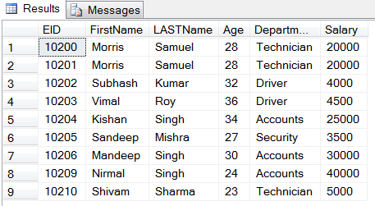
JDBC Program:

import java.sql.Connection;
import java.sql.DriverManager;
import java.sql.ResultSet;
import java.sql.SQLException;
import java.sql.Statement;

public class JdbcEmployees
{
private Connection con;
private Statement st;
private ResultSet rs;

private String strCon =
"jdbc:sqlserver://localhost\\SQLEXPRESS:1434;"
+"database=DB1;"
+"user=sa;"
+"password=1234";
private String strJDBC =
"com.microsoft.sqlserver.jdbc.SQLServerDriver";

public JdbcEmployees()throws ClassNotFoundException, SQLException
{
Class.forName(strJDBC);
con=DriverManager.getConnection(strCon);
st=con.createStatement();
rs=st.executeQuery("SELECT * FROM Employees where Salary>5000");

System.out.print("ID\tFNAME\tLNAME\tAGE\tDEPARTMENT\tSALARY");
System.out.println("");
while(rs.next())
{
System.out.print(rs.getInt(1)+"\t"+rs.getString(2)+"\t"
+rs.getString(3)+"\t"+rs.getInt(4)+"\t"
+rs.getString(5)+"\t"+rs.getInt(6));
System.out.println("");
}
st.close();
con.close();
}

public static void main(String[] args) throws ClassNotFoundException , SQLException
{
JdbcEmployees je=new JdbcEmployees();
}
}
Output:

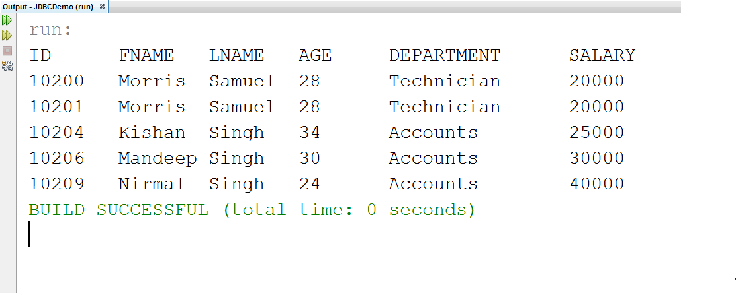

PROGRAM 25 - Write a program using JDBC to fetch the detail of required student from existing database whose id > 4.
Sol:

SQL DATABASE:
USE DB1;
CREATE TABLE StudentsData(
SID INT PRIMARY KEY IDENTITY(1,1),
Name VARCHAR(20) NOT NULL,
Gender VARCHAR(6) NOT NULL CHECK (Gender IN ('Male', 'Female')),
DOB DATE NOT NULL,
Course VARCHAR(10) NOT NULL,
City VARCHAR(10) NOT NULL DEFAULT 'DELHI',);
INSERT INTO StudentsData VALUES('Morris','Male','2000-05-01','BBA',DEFAULT)
INSERT INTO StudentsData VALUES('Subhash','Male','2000-12-07','LLB',DEFAULT)
INSERT INTO StudentsData VALUES('Vimal','Male','1999-11-30','BBA',DEFAULT)
INSERT INTO StudentsData VALUES('Kishan','Male','1998-6-15','BBA',DEFAULT)
INSERT INTO StudentsData VALUES('Sandeep','Male','2002-01-03','BCA',DEFAULT)
INSERT INTO StudentsData VALUES('Mandeep','Male','1999-12-19','MCA','PUNJAB')
INSERT INTO StudentsData VALUES('Priya','Female','2000-09-19','BBA',DEFAULT)
INSERT INTO StudentsData VALUES('Laxman','Male','2004-10-05','BCA','UP')
INSERT INTO StudentsData VALUES('Nirmal','Male','2001-07-29','MBA','MP')
INSERT INTO StudentsData VALUES('Kanchan','Female','1999-12-07','BCA',DEFAULT)
SELECT * FROM StudentsData
EXISTING DATABASE:

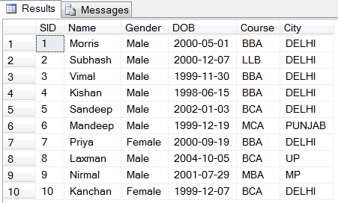
JDBC Program:

import java.sql.Connection;
import java.sql.DriverManager;
import java.sql.ResultSet;
import java.sql.SQLException;
import java.sql.Statement;

public class JdbcStudents
{
private Connection con;
private Statement st;
private ResultSet rs;
private String strCon =
"jdbc:sqlserver://localhost\\SQLEXPRESS:1434;"
+"database=DB1;"
+"user=sa;"
+"password=1234";
private String strJDBC =
"com.microsoft.sqlserver.jdbc.SQLServerDriver";

public JdbcStudents()throws ClassNotFoundException, SQLException
{
Class.forName(strJDBC);
con=DriverManager.getConnection(strCon);
st=con.createStatement();
rs=st.executeQuery("SELECT * FROM StudentsData WHERE SID>4");

System.out.print("SID\tNAME\tGENDER\tDOB\t\tCOURSE\tCITY");
System.out.println("");
while(rs.next())
{
System.out.print(rs.getInt(1)+"\t"+rs.getString(2)+"\t"
+rs.getString(3)+"\t"+rs.getDate(4)+"\t"
+rs.getString(5)+"\t"+rs.getString(6));
System.out.println("");
}
st.close();
con.close();
}

public static void main(String[] args) throws ClassNotFoundException , SQLException
{
JdbcStudents je=new JdbcStudents();
}
}
Output:

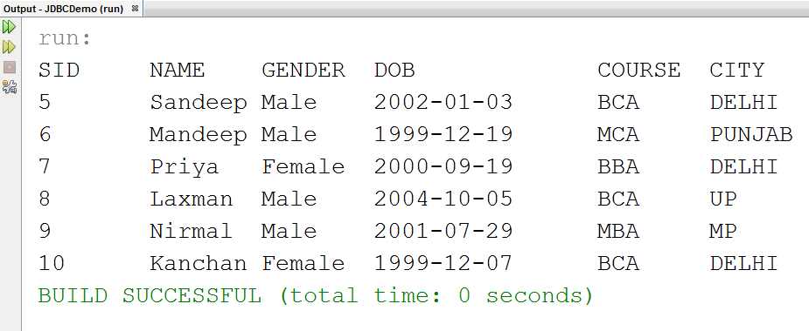
PROGRAM 26 - Write a program using socket programming for data communication between client and server over socket.
Sol:

CLIENT:

import java.net.*;
import java.io.*;

public class Client {
public static void main(String[] args){
try{
Socket ss=new Socket("Localhost",7777);
DataOutputStream dos=new DataOutputStream
(ss.getOutputStream());
dos.writeUTF("Hello Server!!");

dos.close();
ss.close();
}catch (Exception e){
System.out.println("Error!!");
}
}
}

SERVER:

import java.net.*;
import java.io.*;

public class Server {
public static void main(String[] args)
{
try{
ServerSocket ss=new ServerSocket(7777);
Socket s=ss.accept();
DataInputStream dis=new DataInputStream(s.getInputStream());
String str=dis.readUTF();
System.out.println(str);

dis.close();
s.close();
}catch (Exception e){
System.out.println("Error happens!!");
}
}
}
Output:

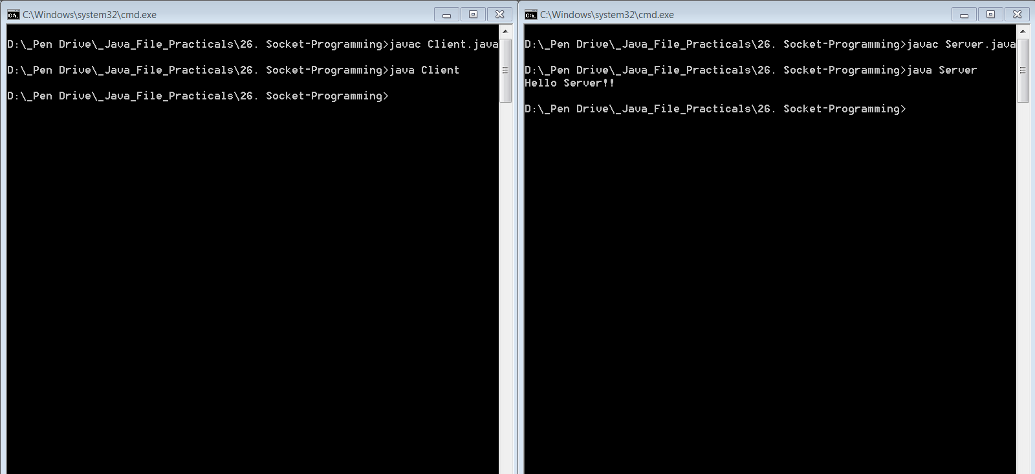
PROGRAM 27 - Write a program using socket programming in which client will receive a value from the user and send it to server over socket connection. Server is responsible for generating the factorial of the given number as well as find the Fibonacci series up to that limit.
Sol:

#include<stdio.h>
#include<time.h>
#include<conio.h>

PROGRAM 28 - Write a program using socket programming to create a chat server application.
Sol:

CLIENT:

import java.net.*;
import java.io.*;

public class Chatclient
{
public static void main(String args[])
{
Try
{
Socket sk=new Socket("192.168.0.103",2000);

BufferedReader sin=new BufferedReader(new InputStreamReader (sk.getInputStream()));
PrintStream sout=new PrintStream(sk.getOutputStream());

BufferedReader stdin=new BufferedReader(new InputStreamReader(System.in));

String s;

while(true)
{
System.out.print("Client : ");

s=stdin.readLine();
sout.println(s);

s=sin.readLine();
System.out.print("Server : "+s+"\n");
if ( s.equalsIgnoreCase("BYE") )
break;
}
sk.close();
sin.close();
sout.close();
stdin.close();
}
catch(Exception e)
{
System.out.print("Exception");
}
}
}
SERVER:

import java.net.*;
import java.io.*;

public class Chatserver
{
public static void main(String args[])
{
try
{
ServerSocket ss=new ServerSocket(2000);
Socket sk=ss.accept();

BufferedReader cin=new BufferedReader(new InputStreamReader (sk.getInputStream()));
PrintStream cout=new PrintStream(sk.getOutputStream());

BufferedReader stdin=new BufferedReader(new InputStreamReader(System.in));

String s;

while(true)
{
s=cin.readLine();
if (s.equalsIgnoreCase("END"))
{
cout.println("BYE");
break;
}
System.out.print("Client : "+s+"\n");
System.out.print("Server : ");
s=stdin.readLine();
cout.println(s);
}
ss.close();
sk.close();
cin.close();
cout.close();
stdin.close();
}
catch(Exception e)
{
System.out.print("Exception");
}
}
}
Output:

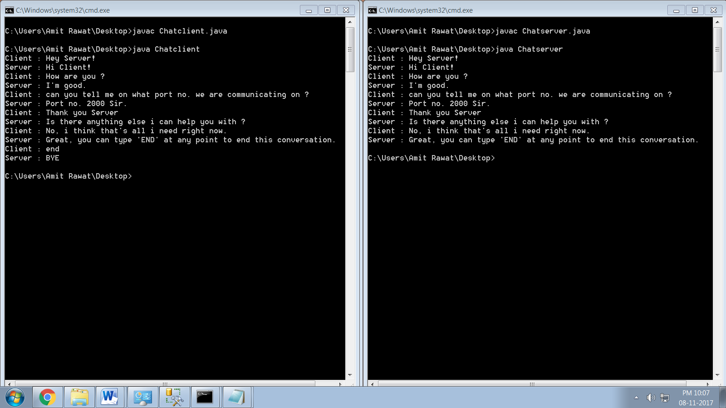
PROGRAM 29 - Write a program to understand the servlet processing.
Sol:

#include<stdio.h>
#include<time.h>
#include<conio.h>
PROGRAM 30 - Write a program to understand the JSP processing.
Sol:

#include<stdio.h>
#include<time.h>
#include<conio.h>

